HENDRICKS REALTY, INC.

Mike Hendricks, Owner/Broker

Debra Miller, Associate Broker
Office: (719) 346-7187
HRI

ADDRESS: 46743 Co. Rd. L, Burlington, CO

LEGAL: 10-acre, more or less, tract in SE/4 Sec. 10-T10S-R44W of the 6th P.M.

HOME STYLE: 1-1/2 Story BUILT: 1937

MAIN LEVEL: 1632 SF (960 main; 672 ½ story) BASEMENT: 960 SF unfin.

BEDROOMS: 1 main; 3 on ½ story BATHROOMS: 1 main; 1 on ½ story

HEATING: Forced Air (natural gas) AIR COND.: Central

GARAGE: 1-car detached

INTERIOR: Plaster/drywall, hardwood, carpet & laminate.

EXTERIOR: Hardiplank siding (3 yrs.), asphalt (Heritage) shingles (3 yrs.), triple-pane vinyl windows (3 yrs).

COMMENTS: This charming 1-1/2 story home has been renovated over the past 3 years to include: new kitchen countertops, appliances; laminate flooring in laundry room; new electrical and insulation on ½ story; updated bathroom on main level; new concrete porch/patio and privacy fence. Existing Oak wood flooring on main level in good condition. Private well and septic. All bedrooms feature large walk-in closets. Sale also includes small 2-bedroom, 1 bath rental home of 952 SF, along with grain bins.

PRICE: $230,000.00

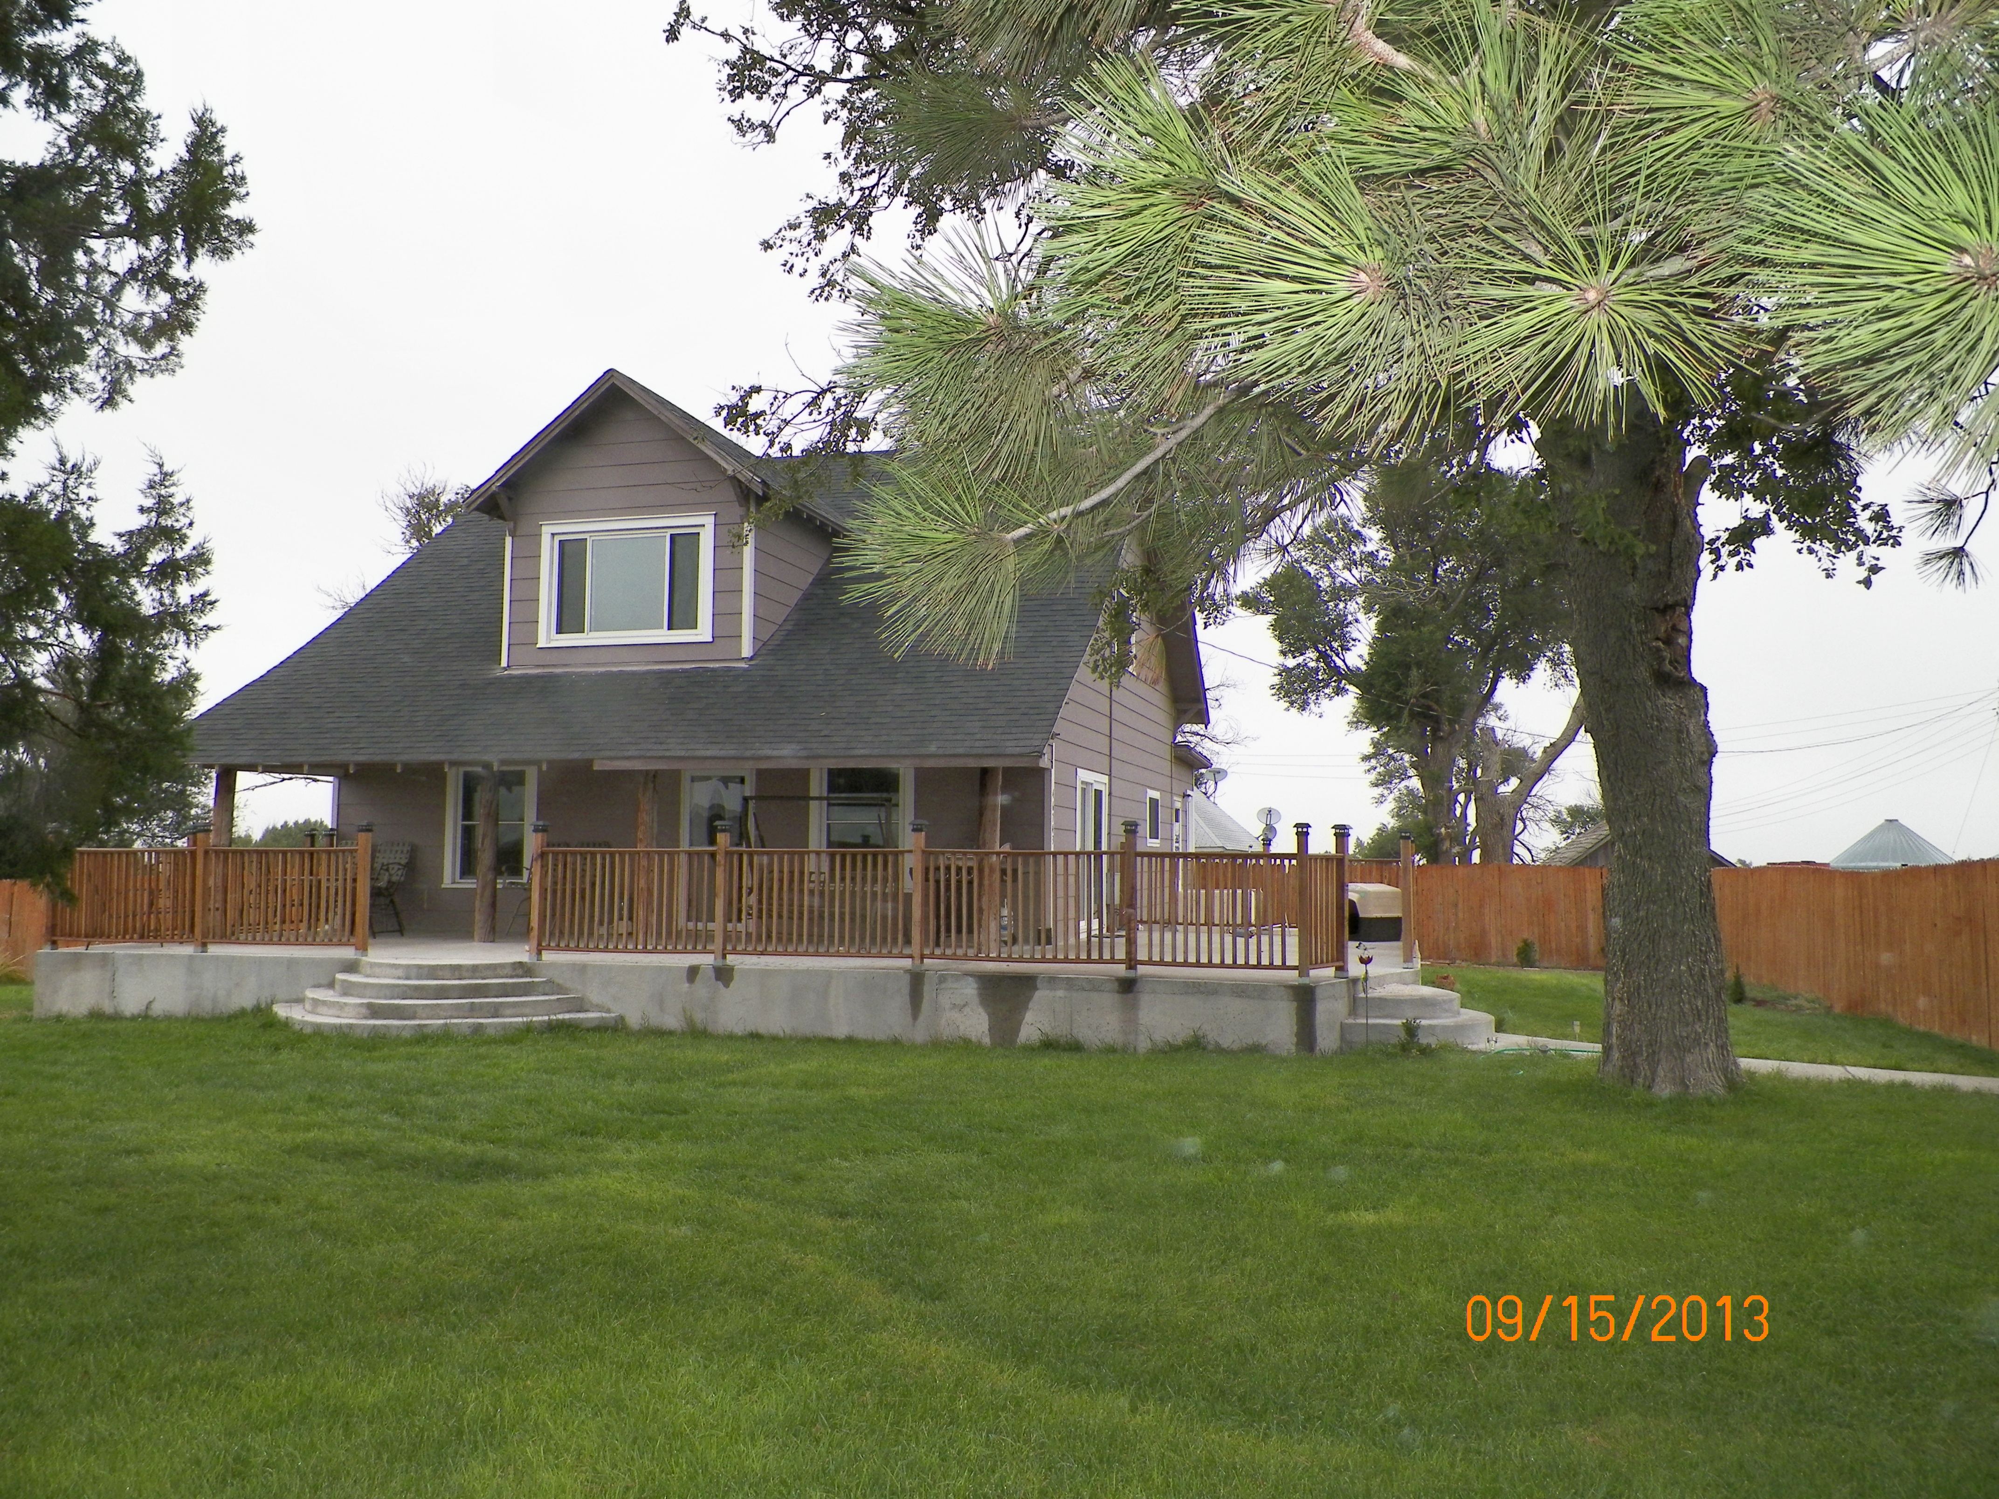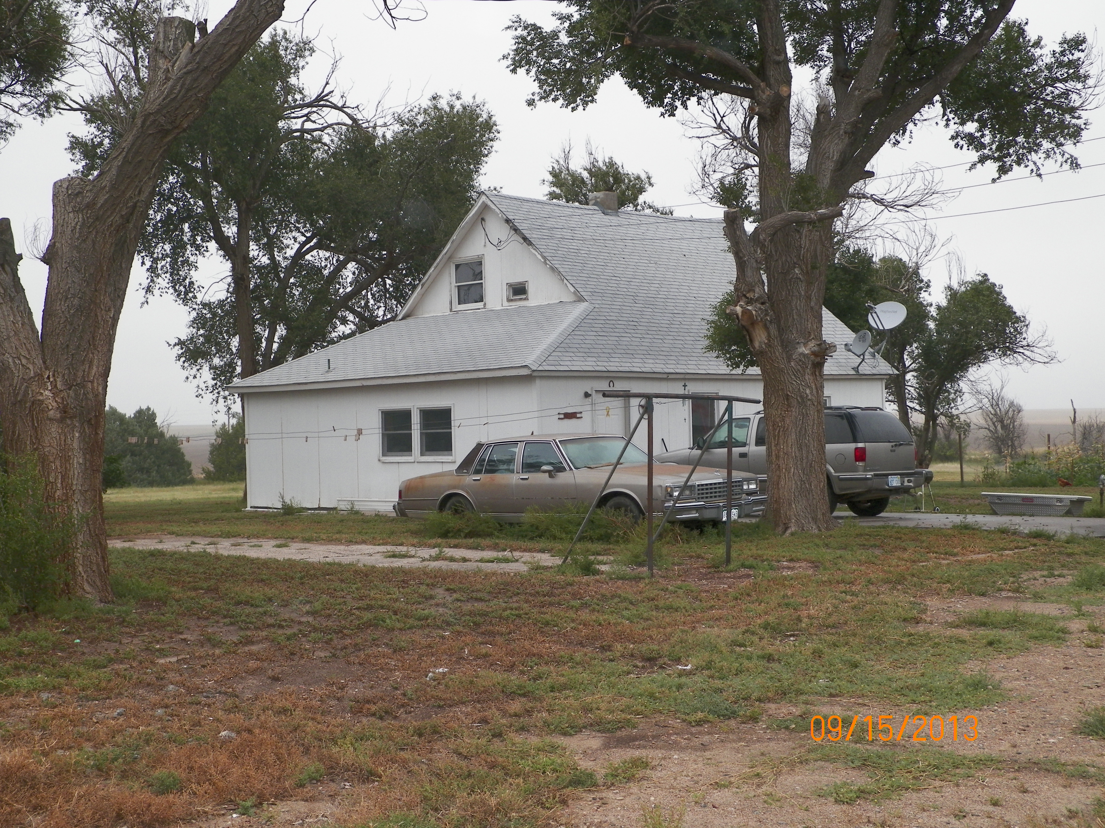
(Rental Home)

The information contained herein, while not guaranteed, has been gathered from sources deemed reliable, however; HENDRICKS REALTY, INC. assumes no responsibility for corrections, omissions, withdrawals or prior sales. HENDRICKS REALTY, INC. IS WORKING AS A TRANSACTION BROKER.

